Press Release | 22 November, 2023

Building Futures Together: The First Annual Summit of Open House Europe in Portugal
Next month, the Lisbon Architecture Triennale will be hosting the first Annual Summit of Open House Europe, an international cooperation project co-funded by the European Union. The summit will feature a Public Programme on December 15–16 related to this year's theme, Building Futures Together, focusing on sustainable practices in our built environment.
The Annual Summit is a gathering of the community of Open House festivals’ organisers, architecture enthusiasts, students, and professionals. Hosted by the Lisbon Architecture Triennale in an 18th-century Palace transformed into a cultural centre, the first Open House Europe Annual Summit will feature a lively programme with three public debates, three guided tours, a workshop, an exhibition and film screenings. It aims to facilitate cross-regional exchange, bringing together perspectives and expertise from diverse fields of knowledge. It is a unique opportunity for the Open House community, including anyone who is planning to launch an Open House festival in their cities, to come together, learn, exchange knowledge, and share experiences.

Three Public Debates
As a collaborative effort by the organisers of Open House Milano, Open House Bilbao, and Open House Lisboa, the Annual Summit showcases an array of international experts. Central to this programme are three public debates, which form the cornerstone of this Summit encompassing moderated discussions and presentations, delve into the theme of sustainability in our cities, exploring it at various scales.
The first panel discussion is about Governance, Architecture, and Sustainability moderated by urban sociology, housing, and cities researcher Sandra Marques Pereira. The panel will include the Director of Urban Planning and Public Space at the City of Milan’s Agency for Mobility, Environment, and Territory Demetrio Scoppeliti, Vice President of the Board of the Institute of Housing and Urban Rehabilitation Filipa Serpa, Deputy Mayor of Barcelona for Ecology, Urban Planning, and Urban Mobility Janet Sanz and Susana Ruiz, who is in charge of the urban planning for the city of Bilbao.
The second discussion will focus on Sustainability in Urban Planning, moderated by an urban planner and the founder of Urbanistica Podcast, Mustafa Sherif. The discussion will feature awarded researcher, professor, and landscape architect Aurora Carapinha, data science enthusiast with expertise in urban mobility Manuel Banza, and architect and researcher Mariana Sanchez Salvador.
The third debate on Achieving Sustainability in Architecture will be moderated by the Curator of Prizes and Programmes at the Fundació Mies van der Rohe, Ivan Blasi. The panel will involve architects Marta Álvarez Pastor from Studio Vaumm, Gianandrea Barreca from Barreca & La Varra, an architecture studio that designed the first Carbon Zero social housing in Europe, and Francisco Adão da Fonseca from Oficina Pedrêz, a studio dedicated to the study of cultivated building materials and infrastructures of self-sufficiency, as well as a founder member of Architects Declare in Portugal.
These three debates will be streamed online on the Open House Europe YouTube channel. The full programme of the event will soon be made available at openhouseeurope.org.

Extended Programme
An Exhibition of Visual Stories submitted by visitors of the Open House festivals across the continent will be unveiled, showcasing stories and experiences of architecture reflecting the theme Building Futures Together.
The programme ends with a Workshop and Guided Tours. Registered participants will be able to learn the benefits and challenges of vertical urban farming systems in a workshop led by Upfarming; visit the Lisbon Drainage Master Plan, and explore the brand new University Residence of Lisbon Public University in Cidade Universitária.

About Open House Europe
Open House Europe is a cooperation project that unfolds a multi-layered view of quality architecture across Europe and unites people of all professions, interests, and visions—from volunteers and curious enthusiasts to young and experienced professionals and organisations. The project encourages and promotes an interest in architecture among these various audiences, helps them gain new perspectives on their local surroundings, and invites them to envision the future of architecture in Europe.
The project currently joins Open House festivals in Athens, Bilbao, Brno, Dublin, Essen, Stockholm, Lisbon, Slovenia, Milan, Tallinn, Thessaloniki, and Vilnius, implemented annually by 11 cultural organisations across the continent. In 2024, Open House Europe will welcome new partners organising festivals in Prague and Vienna, as well as guest cities Copenhagen, Tirana, and Zagreb. Co-funded by the European Union, the project is a new initiative promoting quality architecture in Europe and engaging audiences in a more inclusive debate about the built environment.

Project partners
- Athens and Thessaloniki, EL - Open House Greece;
- Bilbao, ES - Asociación Open Urbanity;
- Brno, CZ - Culture and Management club;
- Dublin, IE - The Irish Architecture Foundation Limited;
- Essen, DE - Forum Kunst & Architektur;
- Stockholm, SE - Open House Stockholm;
- Lisbon, PT - Trienal de Arquitectura de Lisboa;
- Ljubljana, SI - AFRONT zavod za prostorsko inovativnost;
- Milan, IT - Associazione Open House Milano;
- Tallinn, EE - Mittetulundusühing Eesti Arhitektuurikeskus;
- Vilnius, LT - Architekturos fondas.
Open House Europe is coordinated by Architektūros fondas and co-funded by the European Union.
Press Contacts
Open House Europe  Vilius Balčiūnas, Communications Coordinator  vilius@openhouseeurope.org | Lisbon Architecture Triennale  Miguel Santos, International Press Office  miguel.santos@trienaldelisboa.com
Photos and Illustrations
https://drive.google.com/drive/folders/15xkHhJX77FRUHXARWzHLH9QxbOrJcGnq?usp=sharing

Coordinator | Annual Summit Host
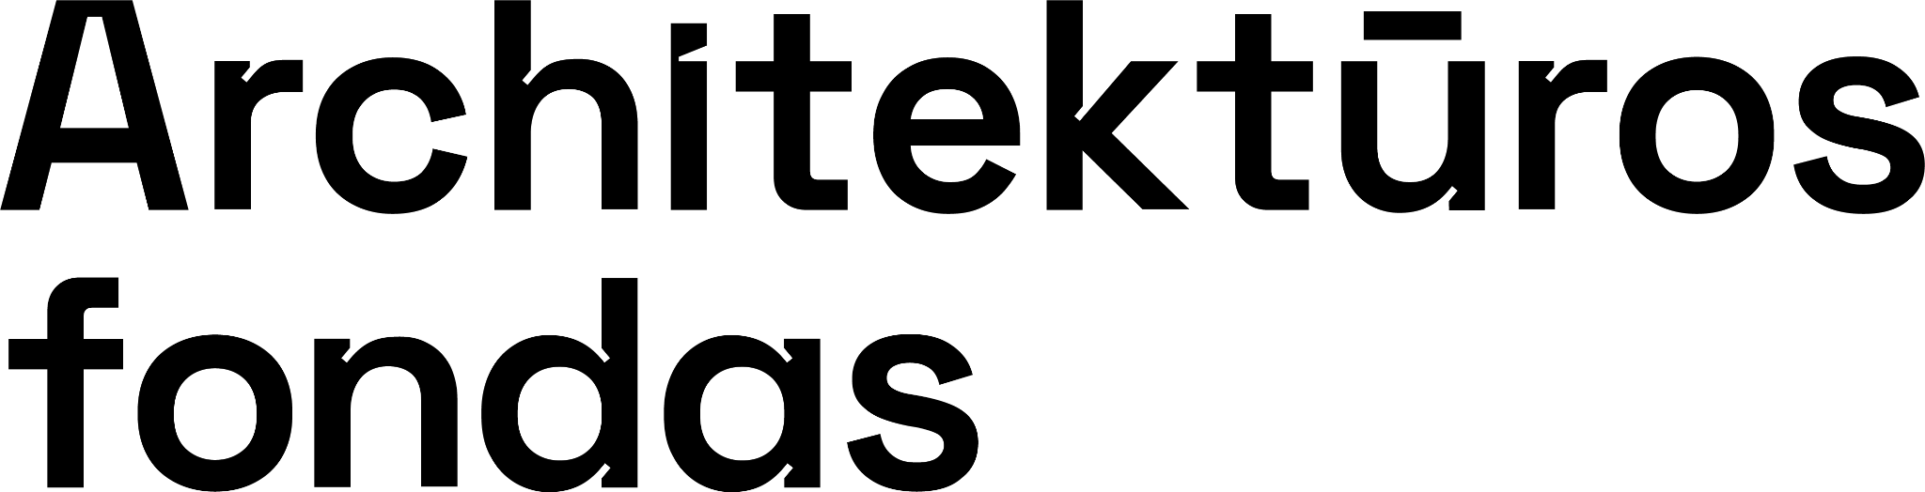 | 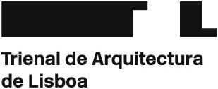

Co-funded by the European Union. Views and opinions expressed are however those of the author(s) only and do not necessarily reflect those of the European Union. Neither the European Union nor the granting authority can be held responsible for them.

